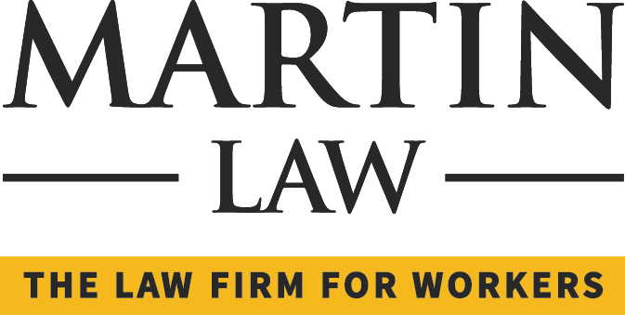
News Release

Date:
March 25, 2016
Contact:
Ashley Scarpone, Marketing Manager, Martin Law: (267) 765-2024, ascarpone@paworkinjury.com

Al Carlson to speak at the Philadelphia Bar Association’s May CLE Program

(Philadelphia) –Martin Law partner Al Carlson will be a presenter at the Philadelphia Bar Association’s May CLE program entitled Litigation Cases Involving Uninsured Employers. The course will explain the complexities of dealing with ”uninsured” employers and ways to potentially reach a settlement.

Al Carlson is a partner of Martin Law and practices exclusively in the area of workers’ compensation law since 1992. In addition to maintaining an active case load, Mr. Carlson is a frequent guest lecturer at Villanova University School of Law in the area of Pennsylvania workers’ compensation. Al served as a faculty member for a Continuing Legal Education (CLE) course entitled “I Know What you Did Last Weekend: Use of Social Media in Workers’ Compensation Litigation” in March 2014. He has also published numerous articles on the subject. Mr. Carlson served as a Co-Chair in 2008 for the Philadelphia Bar Association’s Workers’ Compensation Section and also served as the legislative liaison. He was elected to the Board of Directors for the Philadelphia Trial Lawyers Association in June 2010.

With sixteen attorneys and five offices in Bristol, Allentown, Reading, Malvern and Philadelphia, Martin Law is one of the largest firms in Pennsylvania of its kind, focusing solely on Workers’ Compensation, Social Security Disability, Long Term Disability and Veterans’ Benefits.

# # #

Photos (attached): Al Carlson, Esq.

